SENTIMENT ANALYSIS

Sentiment Analysis, or Opinion Mining, is a sub-field of Natural Language Processing (NLP) that tries to identify and extract opinions within a given text. The aim of sentiment analysis is to gauge the attitude, sentiments, evaluations, attitudes and emotions of a speaker/writer based on the computational treatment of subjectivity in a text.

Problem Statement:

Find the sentiment of the given text i.e., if the text is positive,negative or neutral

1.Using Vader :

VADER (Valence Aware Dictionary and sEntiment Reasoner) is a lexicon and rule-based sentiment analysis tool that is specifically attuned to sentiments expressed in social media. VADER uses a combination of A sentiment lexicon is a list of lexical features (e.g., words) which are generally labeled according to their semantic orientation as either positive or negative or neutral.

The program code is as follows:

import nltk
#nltk.download('vader_lexicon')
from nltk.tokenize import word_tokenize, RegexpTokenizer
from nltk.sentiment.vader import SentimentIntensityAnalyzer
sentence = str(input("Enter the text you want find sentiment for :\n"))
tokenized_sentence = nltk.word_tokenize(sentence)

sid = SentimentIntensityAnalyzer()
pos_word_list=[]
neu_word_list=[]
neg_word_list=[]

for word in tokenized_sentence:
if (sid.polarity_scores(word)['compound']) >= 0.1:
pos_word_list.append(word)
elif (sid.polarity_scores(word)['compound']) <= -0.1:
neg_word_list.append(word)
else:
neu_word_list.append(word)

print('Positive words list:',pos_word_list)
print('Neutral words list:',neu_word_list)
print('Negative words list:',neg_word_list)
score = sid.polarity_scores(sentence)
#print('\nScores:', score)

posit = sid.polarity_scores(sentence)['pos']
negat = sid.polarity_scores(sentence)['neg']
neut = sid.polarity_scores(sentence)['neu']

print('\n')

print('Positive score is',sid.polarity_scores(sentence)['pos']*100,'%')
print('Neutral score is',sid.polarity_scores(sentence)['neu']*100,'%')
print('Negative score',sid.polarity_scores(sentence)['neg']*100,'%')

if posit >= negat and posit >=neut :
print('Overall Sentiment score: Positive')
elif negat > posit and negat>=neut:
print('Overall Sentiment score : Negative')
else:
print('Overall Sentiment score : Neutral')

Output :
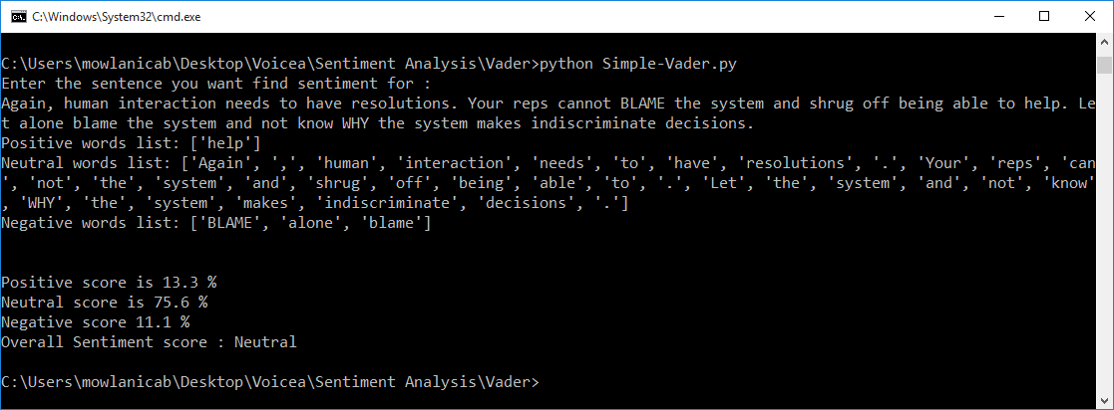

- Using sklearn(Bernoulli’s Naive Bayes):

In this,Bernoulli’s Naive Bayes theorem is used which was trained on positive and negatively tagged sentences

The code is as follows:
# -*- coding: utf-8 -*-
"""Sentiment-Analysis.ipynb

Automatically generated by Colaboratory.

Original file is located at
https://colab.research.google.com/drive/1IB1giYG619XnyOG7e5Nw6EPSe439Pj70

https://github.com/gabrielschade/IA/blob/master/ClassificacaoComentariosComNaiveBayes/sentiment.ipynb

"""

### Importing the required libraries

from sklearn.feature_extraction.text import CountVectorizer
from sklearn.naive_bayes import BernoulliNB
from sklearn.metrics import confusion_matrix,classification_report

import numpy as np
import itertools
import matplotlib.pyplot as plt
import pandas
import urllib.request as request

"""### Loading the datasets"""

def get_all_data():
root = "C:/Users/mowlanicab/Desktop/Voicea/Sentiment Analysis/Datasets/"
with open(root + "output-onlinerandomtools.txt","r") as text_file:
data = text_file.read().split('\n')

return data
'''
with open(root + "imdb_labelled.txt", "r") as text_file:
data = text_file.read().split('\n')

with open(root + "amazon_cells_labelled.txt", "r") as text_file:
data += text_file.read().split('\n')

with open(root + "yelp_labelled.txt", "r") as text_file:
data += text_file.read().split('\n')
'''

values = get_all_data()
"""
print(values[0])
print(values[10])
print(values[100])
print(values[1000])
"""

"""### Preprocessing of data"""

def preprocessing_data(data):
processing_data = []
for single_data in data:
if len(single_data.split("\t")) == 2 and single_data.split("\t")[1] != "":
processing_data.append(single_data.split("\t"))

return processing_data

all_data = get_all_data()
values = preprocessing_data(all_data)
#print(values[0])
#print(values[10])

"""### Split Data"""

def split_data(data):
total = len(data)
training_ratio = 0.75
training_data = []
evaluation_data = []

for indice in range(0, total):
if indice < total * training_ratio:
training_data.append(data[indice])
else:
evaluation_data.append(data[indice])

return training_data, evaluation_data

"""### Preprocessing Step"""

def preprocessing_step():
data = get_all_data()
processing_data = preprocessing_data(data)

return split_data(processing_data)

"""### Training the dataset"""

def training_step(data, vectorizer):
training_text = [data[0] for data in data]
training_result = [data[1] for data in data]

training_text = vectorizer.fit_transform(training_text)

return BernoulliNB().fit(training_text, training_result)

"""### Score Step"""

training_data, evaluation_data = preprocessing_step()
vectorizer = CountVectorizer(binary = 'true')
classifier = training_step(training_data, vectorizer)
result = classifier.predict(vectorizer.transform(["I love this movie!"]))

#print(result[0])

def analyse_text(classifier, vectorizer, text):
return text, classifier.predict(vectorizer.transform([text]))

new_result = analyse_text(classifier, vectorizer, "Best product ever")
#print(new_result)

def print_result(result):
text, analysis_result = result

if analysis_result[0]=='1':
print_text= "Positive"
elif analysis_result[0]=='-1':
print_text = "Negative"
else:
print_text = "Neutral"
print(text, ":", print_text)

#print_result(new_result)

"""### More Examples

print_result( analyse_text(classifier, vectorizer,"this is the best movie"))
print_result( analyse_text(classifier, vectorizer,"this is the worst movie"))
print_result( analyse_text(classifier, vectorizer,"awesome!"))
print_result( analyse_text(classifier, vectorizer,"10/10"))
print_result( analyse_text(classifier, vectorizer,"so bad"))
print_result( analyse_text(classifier, vectorizer,"nice"))
print_result( analyse_text(classifier, vectorizer,"Marilyn Monroe had six toes"))

"""
### Evaluation

def simple_evaluation(evaluation_data):
evaluation_text = [evaluation_data[0] for evaluation_data in evaluation_data]
evaluation_result = [evaluation_data[1] for evaluation_data in evaluation_data]

total = len(evaluation_text)
corrects = 0
for index in range(0, total):
analysis_result = analyse_text(classifier, vectorizer, evaluation_text[index])
text, result = analysis_result
corrects += 1 if result[0] == evaluation_result[index] else 0

return corrects * 100 / total

#print(simple_evaluation(evaluation_data))

### Confusion Matrix

def create_confusion_matrix(evaluation_data):
evaluation_text = [evaluation_data[0] for evaluation_data in evaluation_data]
actual_result = [evaluation_data[1] for evaluation_data in evaluation_data]
prediction_result = []
for text in evaluation_text:
analysis_result = analyse_text(classifier, vectorizer, text)
prediction_result.append(analysis_result[1][0])

matrix = confusion_matrix(actual_result, prediction_result)
return matrix

confusion_matrix_result = create_confusion_matrix(evaluation_data)
#print(confusion_matrix_result)

## Converting Confusion matrix to Dataframe
pandas.DataFrame(confusion_matrix_result, columns=["Positive", "Negative","Neutral"],index=["Positive", "Negative","Neutral"])

def create_classification_report(evaluation_data):
evaluation_text = [evaluation_data[0] for evaluation_data in evaluation_data]
actual_result = [evaluation_data[1] for evaluation_data in evaluation_data]
prediction_result = []
for text in evaluation_text:
analysis_result = analyse_text(classifier,vectorizer,text)
prediction_result.append(analysis_result[1][0])

report = classification_report(actual_result,prediction_result)
return report

classification_report_result = create_classification_report(evaluation_data)
#print(classification_report_result)

print("Enter the text you want to analyze:")
input = str(input())
print_result( analyse_text(classifier, vectorizer,input))

Output:
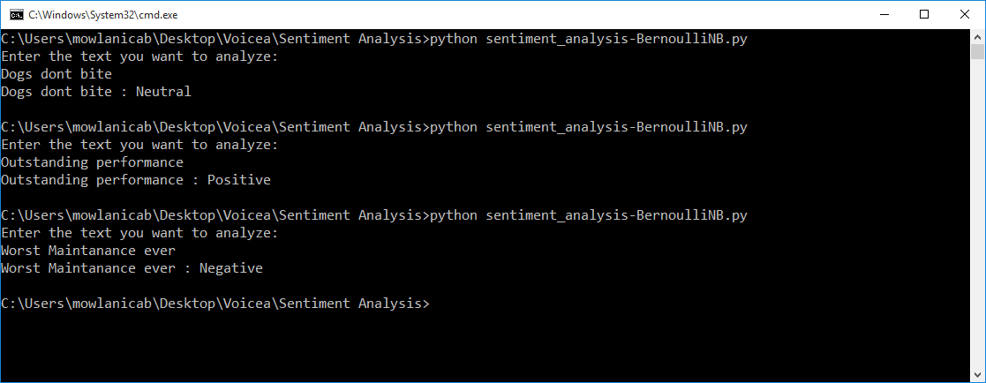

3.Using Textblob :

TextBlob is a Python (2 and 3) library for processing textual data. It provides a simple API for diving into common natural language processing (NLP) tasks such as part-of-speech tagging, noun phrase extraction, sentiment analysis, classification, translation, and more.

Text blob gives the positive and negative score and also the overall Sentiment of the text

The sentiment property returns a named tuple of the form Sentiment(polarity,subjectivity). The polarity score is a float within the range [-1.0, 1.0]. The subjectivity is a float within the range [0.0, 1.0] where 0.0 is very objective and 1.0 is very subjective.

The code is as follows:

In this , we are using Naive Bayes classifier

from textblob import TextBlob
from textblob.sentiments import NaiveBayesAnalyzer
import nltk
#nltk.download('movie_reviews')
#nltk.download('punkt')

text = str(input("Enter the text you want you find sentiment for:"))

sent = TextBlob(text)
# The polarity score is a float within the range [-1.0, 1.0]
# where negative value indicates negative text and positive
# value indicates that the given text is positive.
polarity = sent.sentiment.polarity
# The subjectivity is a float within the range [0.0, 1.0] where
# 0.0 is very objective and 1.0 is very subjective.
subjectivity = sent.sentiment.subjectivity

sent = TextBlob(text, analyzer = NaiveBayesAnalyzer())
classification= sent.sentiment.classification
positive = sent.sentiment.p_pos
negative = sent.sentiment.p_neg

print("Polarity:",polarity)

print("Subjectivity:",subjectivity)

print("Classification:",classification)

print("Positive score:",positive*100)

print("Negative score:",negative*100)

Output:
